CS 2301-01 Operating Systems 1

Instructor: Professor Ravichandran Purushothaman

Name: Anonymos

Written Assignment Unit 5

Memory management is a crucial concept in modern programming. In particular, understanding the mechanisms of the stack and heap is essential for writing efficient code. The stack is used for temporary data storage, while the heap is used for dynamic memory allocation. This paper will use diagrams to explain the functions of the stack and heap and the workings of virtual memory addressing. As shown in research from Carnegie Mellon University, effective memory management is directly linked to program performance and reliability (Silberschatz et al., 2018).

**Memory Process**

First, to visually understand the memory process, we present the following diagram. This diagram illustrates the basic mechanisms of memory and virtual memory addressing.

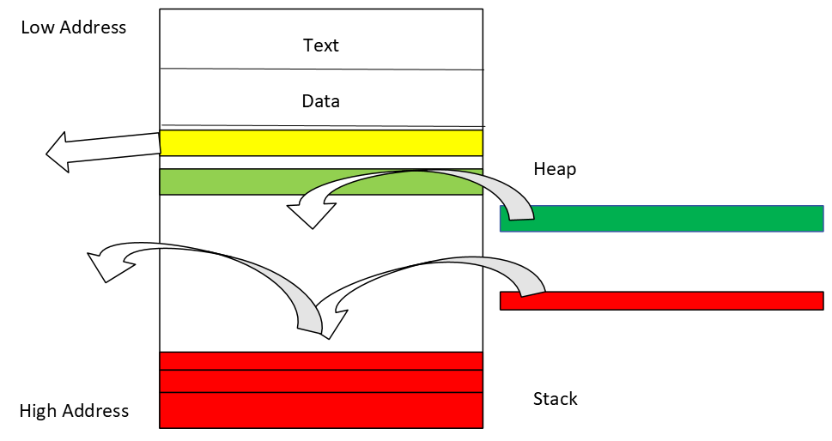

This diagram simply illustrates the movement of the stack and heap in the memory process. The stack is mainly used for function calls and local variable storage, managed in a LIFO (Last In, First Out) manner. The heap is used for dynamic memory allocation, with memory being allocated as needed during program execution.

**Explanation of Memory and Virtual Memory Addressing**

Memory management consists of two main areas: the stack and the heap. The stack is used for temporarily storing function calls and local variables, while the heap is used for storing dynamic data. Virtual memory is a technique that compensates for the lack of physical memory, enabling efficient memory management by converting virtual addresses to physical addresses. According to research from the University of California, Berkeley, virtual memory significantly enhances the efficiency and stability of programs (Tanenbaum & Bos, 2015).

Functions and Uses of the Heap

The heap is a region used for dynamically allocating memory during program execution. It is used for creating objects and data structures, such as linked lists and trees. Garbage collection automatically frees unnecessary memory.

Functions and Uses of the Stack

The stack stores necessary information (e.g., return addresses and local variables) during function calls. A stack frame is created for each function call and is released when the function terminates.

**Detailed Explanation of Stack and Heap**

Details of the Heap

The heap is used for dynamic memory allocation. Memory is allocated using functions such as malloc or new, and released using free or delete. Managing the heap is more complex than managing the stack and carries risks of memory leaks and fragmentation. As shown in the diagram, dynamic allocation of address space can lead to fragmentation throughout the memory area, but it allows for adequate allocation of the necessary address space.

Details of the Stack

The stack is managed in a LIFO (Last In, First Out) manner. A stack frame is created during function calls and released when the function terminates. This method is fast and efficient but has size limitations. As illustrated in the diagram, the stack uses pre-allocated areas sequentially.

**Conclusion**

Memory management is an indispensable skill for writing efficient and bug-free programs. Understanding the differences and characteristics of the stack and heap allows for more effective memory utilization. It is essential for junior programmers to grasp the basic concepts of memory management and apply them in actual programming. As demonstrated by research institutions, proper memory management significantly improves program performance and reliability.

Word Count: 523

References

1. Silberschatz, A., Galvin, P. B., & Gagne, G. (2018). *Operating System Concepts* (10th ed.). Wiley.
2. Tanenbaum, A. S., & Bos, H. (2015). *Modern Operating Systems* (4th ed.). Pearson.